# OSN IP table: Task_1:

| **Device** | **Interface** | **IP Address or Network** | **Default Gateway** |
| --- | --- | --- | --- |
| LAN1 | LAN1 | LAN1 | LAN1 |
| ISP router | Se0/0/0 | 2.2.2.222/24 | N/A |
|  |  |  |  |
| LAN2 | LAN2 | LAN2 | LAN2 |
| Sever | G0/1 | 192.168.23.50/30 | 192.168.23.49/30 |
|  |  |  |  |
| CISCO router | Gig0/2 | 192.168.23.49/30 | N/A |
| Se0/0/1 | 2.2.2.223/24 | N/A |
| Gig0/1 | 192.168.23.33/28 | N/A |
| Gig0/0 | 192.168.23.1/27 | N/A |
|  |  |  |  |
| LAN3 | LAN3 | LAN3 | LAN3 |
| Switch | VLAN1 | 192.168.23.2/27 | 192.168.23.1/27 |
| Printer | NIC | 192.168.23.3/27 | 192.168.23.1/27 |
| Admin1 | NIC | 192.168.23.18/27 | 192.168.23.1/27 |
| Admin2 | NIC | 192.168.23.17/27 | 192.168.23.1/27 |
| Admin3 | NIC | 192.168.23.16/27 | 192.168.23.1/27 |  |
| Admin4 | NIC | 192.168.23.15/27 | 192.168.23.1/27 |
| Admin5 | NIC | 192.168.23.14/27 | 192.168.23.1/27 |
| Admin6 | NIC | 192.168.23.13/27 | 192.168.23.1/27 |
| Admin7 | NIC | 192.168.23.12/27 | 192.168.23.1/27 |
| Admin8 | NIC | 192.168.23.11/27 | 192.168.23.1/27 |
| Admin9 | NIC | 192.168.23.10/27 | 192.168.23.1/27 |
| Admin10 | NIC | 192.168.23.9/27 | 192.168.23.1/27 |
| Admin11 | NIC | 192.168.23.8/27 | 192.168.23.1/27 |
| Admin12 | NIC | 192.168.23.7/27 | 192.168.23.1/27 |
| Admin13 | NIC | 192.168.23.6/27 | 192.168.23.1/27 |
| Admin14 | NIC | 192.168.23.5/27 | 192.168.23.1/27 |
| Admin15 | NIC | 192.168.23.4/27 | 192.168.23.1/27 |
| Management1 | NIC | 192.168.23.21/27 | 192.168.23.1/27 |
| Management2 | NIC | 192.168.23.20/27 | 192.168.23.1/27 |
| Management3 | NIC | 192.168.23.19/27 | 192.168.23.1/27 |
|  |  |  |  |
| LAN4 | LAN4 | LAN4 | LAN4 |
| Switch2 | VLAN1 | 192.168.23.34/28 | 192.168.23.33/28 |
| Accountant1 | NIC | 192.168.23.37/28 | 192.168.23.33/28 |
| Accountant2 | NIC | 192.168.23.36/28 | 192.168.23.33/28 |
| Accountant3 | NIC | 192.168.23.35/28 | 192.168.23.33/28 |
| Accountant4 | NIC | 192.168.23.38/28 | 192.168.23.33/28 |
| Accountant5 | NIC | 192.168.23.39/28 | 192.168.23.33/28 |
| Accountant6 | NIC | 192.168.23.40/28 | 192.168.23.33/28 |
| Accountant7 | NIC | 192.168.23.41/28 | 192.168.23.33/28 |
| Accountant8 | NIC | 192.168.23.42/28 | 192.168.23.33/28 |
| Accountant9 | NIC | 192.168.23.43/28 | 192.168.23.33/28 |
| Accountant10 | NIC | 192.168.23.44/28 | 192.168.23.33/28 |
| Access point | NIC | 192.168.23.45/28 | 192.168.23.33/28 |
| Laptop | Wireless | 192.168.23.46/28 | 192.168.23.33/28 |

# OSN ping results: Task_1:

## Admin computer to the Server: ping test from admin1, Lan 3 to server0, Lan 2.

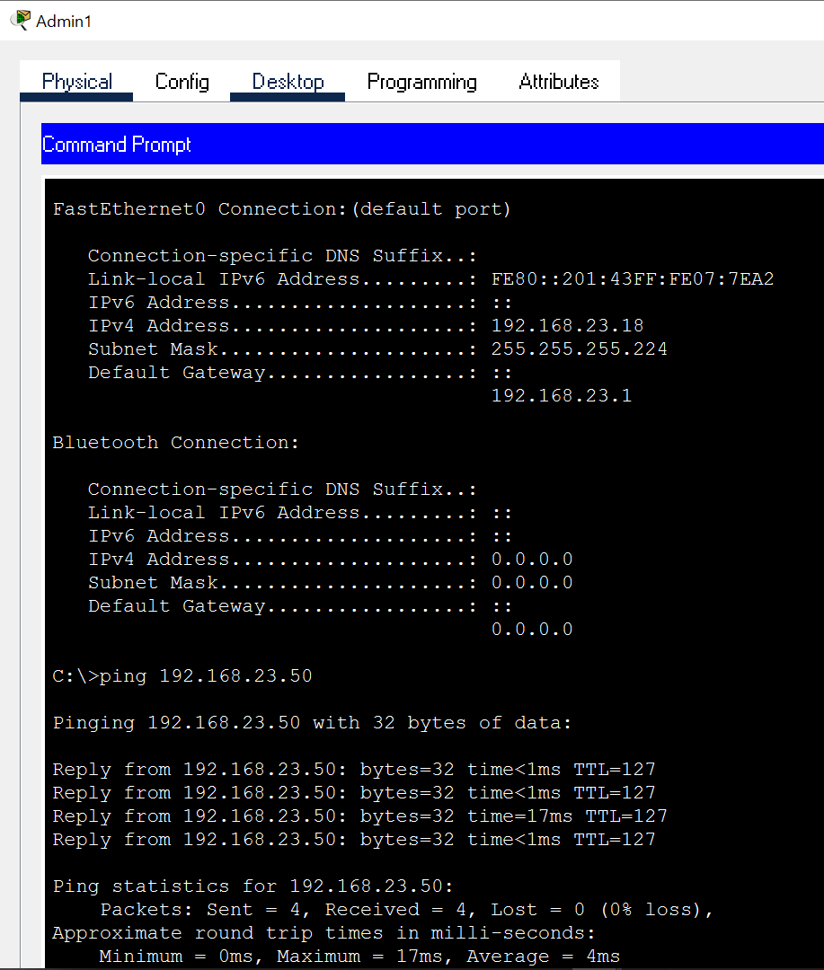

## Management computer to accountant: ping test from management1, Lan 3 to accountant1, Lan 4.

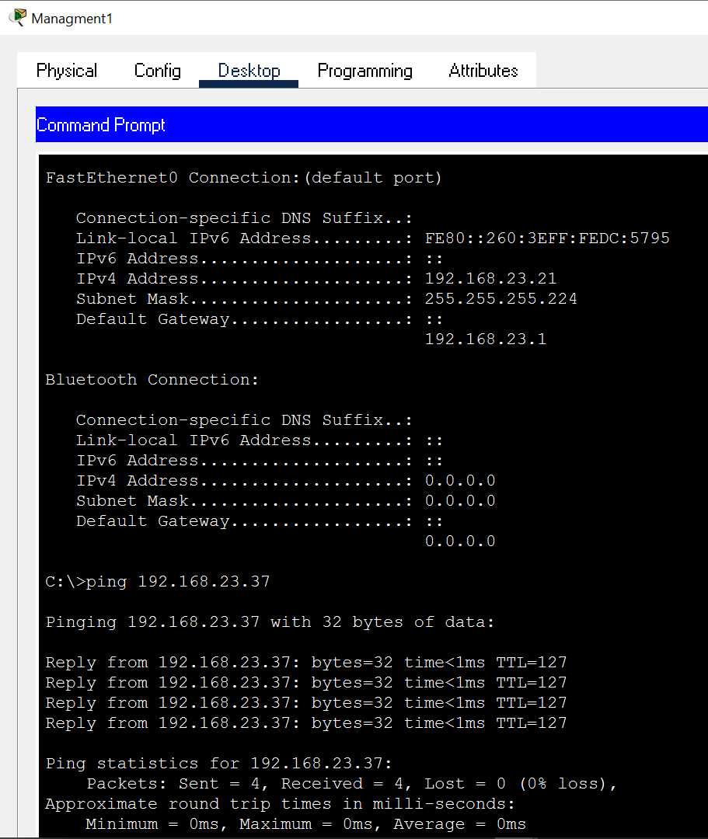

## Wireless laptop to ISP: ping test from Laptop, Lan 4 to isp-Router, Lan 1

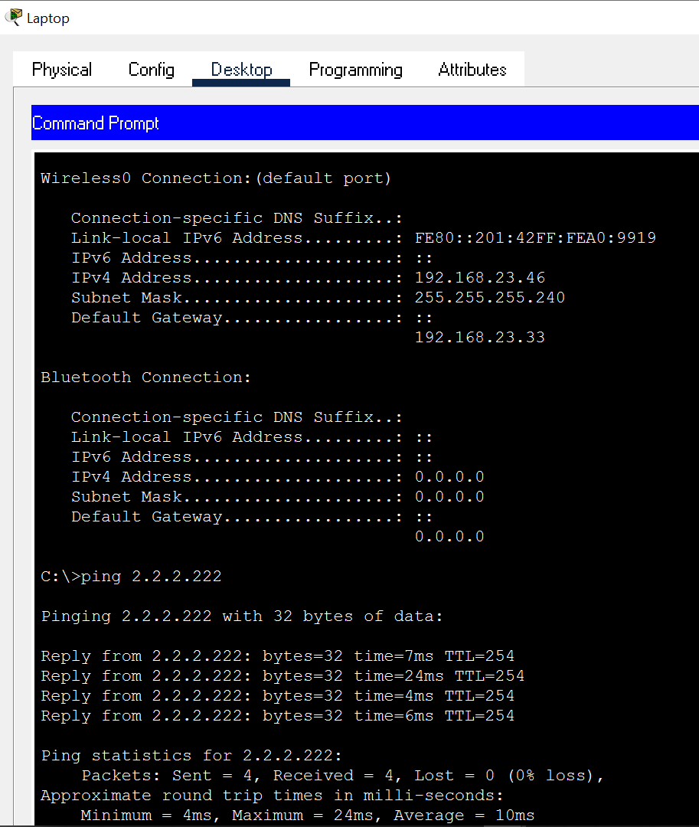

## Admin to ISP: ping test from Admin1, Lan 3 to isp-Router, Lan 1.

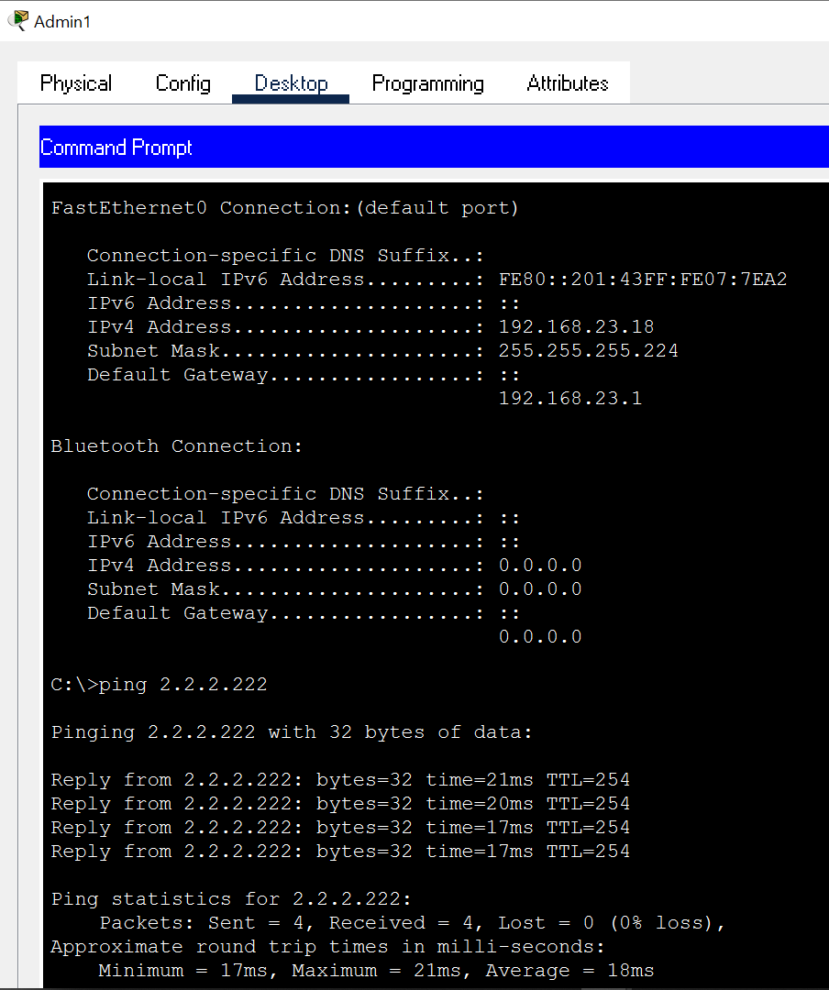

# Appendix:

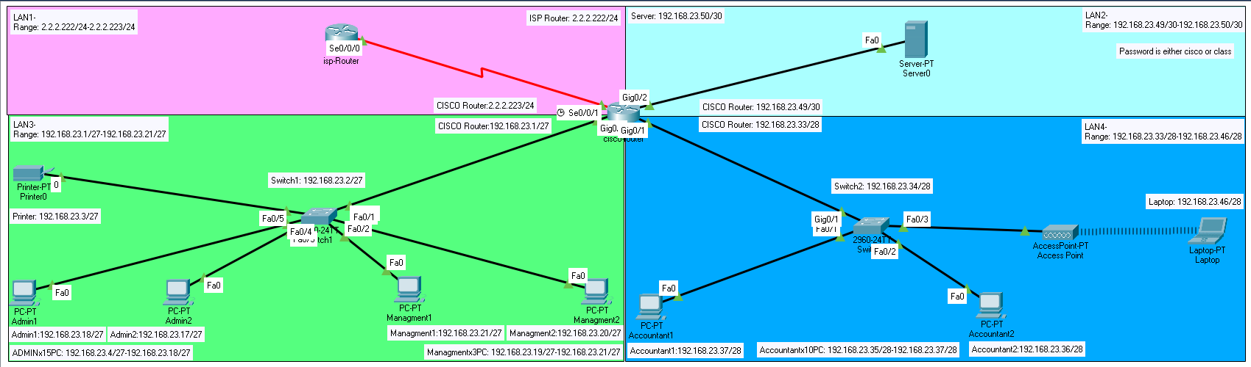Figure 1: